Activity 6: DevOps and Cloud Research

Ryan Coon

CST-323

Professor Dan Neal

April 23, 2023

DevOps logging:

Screenshot of example log file output from the test application deployed

Why is adding robust logging important for an application deployed to the cloud?

It helps us on the back end see what is going on with the site and any errors firsthand through the logs to find out exactly where in the code we would need to start.

What are three features of the logging framework that you did not implement, but would be important to implement for a production-level application?

Debug, trace, error

What are two enterprise class logging products besides Loggly that could be used to search and archive application or system log files?

New Relic

Manage Engine

3. DevOps Monitoring:

What is the purpose for setting up a log file alert?

Alerts us on the backend for specific events set to alert.

What is the purpose for setting up an application availability alert?

Lets us on the back end know if the application is up or not without having to open the app.

4. DevOps CI/CD:

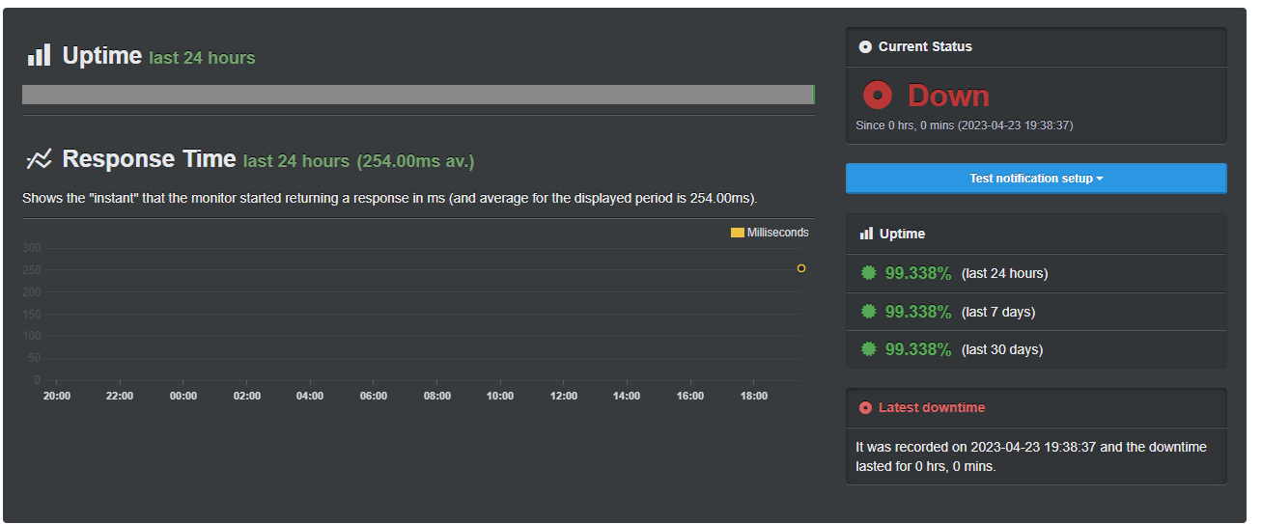

What roles do Maven and Composer play when supporting CI/CD?

Maven and Composer play a crucial role in supporting CI/CD by automating the build and deployment process, managing dependencies, and improving build speed.

What role does a Source Control System play when supporting CI/CD?

SCS serves as a repository for source code and other artifacts that are developed by developers in the software development lifecycle. It enables developers to store, track, and manage changes to source code, documentation, and configuration files.

How did your chosen build pipeline tool support CI/CD?

Besides build and deployment, what are three other features that could be integrated into a build pipeline to support a robust CI/CD?

Automated Testing: One essential aspect of CI/CD is automated testing, which can help identify issues and defects early in the development process. Integrating automated tests into the build pipeline can help ensure that each new code commit is thoroughly tested and that any issues are identified and resolved quickly.

Code Analysis: Incorporating code analysis tools into the build pipeline can help identify potential code quality issues, security vulnerabilities, and performance bottlenecks. By integrating code analysis into the pipeline, developers can be alerted to potential issues before the code is deployed, reducing the risk of problems in production.

Continuous Deployment: Continuous deployment involves automatically deploying code changes to production as soon as they are approved by the build and testing process. This approach can help reduce the time between code changes and deployment, which can lead to faster feedback and more rapid iteration. However, it is important to have a robust testing and monitoring process in place to ensure that changes are deployed safely and without introducing issues into the production environment.

5. Cloud computing research questions

Read the assigned textbook required readings for this topic. What data information is relevant and should be provided in a log file to support your application in the cloud? Provide three best practices that you should adhere to when adding logging to an application. Provide three issues or risks that could occur if inadequate logging is designed into an application.

Research three tools that could support a CI/CD build pipeline. What are the tools and how are they used to support CI/CD?

Jenkins - This is an open-source automation server that hosts a CI/CD process. It works on Windows, MacOS, and Unix-based systems. It relies on a sizable library of plugins which allow the system to build a variety of software projects.

CircleCI - This system integrates heavily with GitHub, GitLab, and BitBucket repositories to automate testing and deployment, both on a cloud-hosted option or private infrastructure. It boasts a quick setup and great support for automated testing.

Buddy - Much like CircleCI, this system deploys code from GitHub, GitLab, or Bitbucket repositories. It uses Docker containers with pre-installed languages and framework tools, which include those for status notifications and monitoring, to build software. Like Heroku, this service offers attachments to 3rd party services like MariaDB, Elastic, PostgreSQL, RabbitMQ, Redis, and some others.

From Chapter 14 in the textbook, identify five capabilities that drive the definition of DevOps. What are the five capabilities and how are these used to help improve application development, testing, and delivery

Automate Infrastructure

The process of deploying code in a smooth system is only possible if the infrastructure runs on is consistently dependable, as far as its configuration. Plenty of these options are available now through IaaS and PaaS solutions.

Automate Deployments

Automating deployments involves connecting the deployment process to the team's source control service or repository. These forms of automation usually pick up small, incremental changes to the main source control branch (and peripheral feature or test branches) and run the new source through the CI/CD pipeline for its respective environment. This ensures that breakages are found faster and addressed speedily. There's likely a lot of less finger-pointing and group debugging sessions when it's easier to know who and what code broke the build.

Design For Feature Flags

This is a method of designing applications and their deployment in such a way that it's almost modular. If this is done properly, then a production build can be configured to only allow certain features to be accessible for specific user groups, in order to test smaller features before mass-distributing them. A modern-day example of this might be when Instagram removed it's "like" count from peoples' posts, but only for specific user regions.

Measure, Monitor, Experiment

In a well-rounded DevOps environment, systems will be in place that allows developers to monitor different portions of the application for insights into bugs or potential future fixes. These sorts of monitoring services work in conjunction with things like feature flags to make sure developers can "fail fast" and iterate quickly through designs.

Continuous Integration and Continuous Delivery

This is what most people think is primarily involved in DevOps. CI relates to testing the code contributed by developers to the central codebase repository system. CD relates to grabbing that source code and transforming it into a deployable package for consumption by the end user.

References:

Katalon. (2023, March 23). Best 14 CI/CD Tools You Must Know | Updated For 2023. katalon.com. https://katalon.com/resources-center/blog/ci-cd-tools

Kavis, M. J. (2014). Architecting the cloud: Design decisions for cloud computing service models (SaaS, PaaS, and IaaS). Wiley.